**English II**

**Unit 3**

**Present continuous**

[**https://www.linkedin.com/pulse/future-work-changing-job-market-rohit-kumar/**](https://www.linkedin.com/pulse/future-work-changing-job-market-rohit-kumar/)

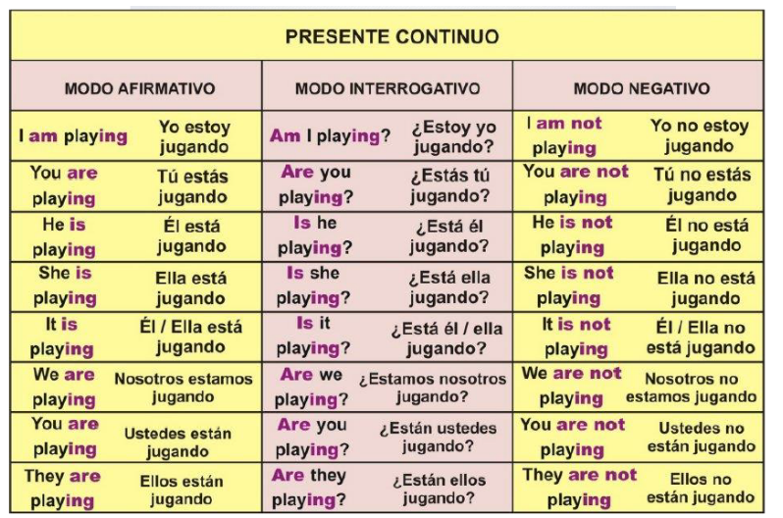

**We use the present continuous to talk about:**

**✅activities at the moment of speaking:**

I'm just leaving work. I'll be home in an hour.

Please be quiet. The children are sleeping.

**✅future plans or arrangements:**

Mary is going to a new school next term.

What are you doing next week?

**✅something which is happening before and after a specific time:**

At eight o'clock we are usually having breakfast.

When I get home the children are doing their homework.

**✅ something which we think is temporary:**

Michael is at university. He's studying history.

I'm working in London for the next two weeks.

**✅ something which is new and contrasts with a previous state:**

These days most people are using email instead of writing letters.

What sort of clothes are teenagers wearing nowadays?

What sort of music are they listening to?

**✅ something which is changing, growing or developing:**

The children are growing up quickly.

The climate is changing rapidly.

Your English is improving.

**✅ something which happens again and again:**

It's always raining in London.

They are always arguing.

George is great. He's always laughing.

👀 Note that we normally use ‘**always**’ with this use.

Stative verbs

We do not normally use the continuous **with stative verbs**. Stative verbs include:

* verbs of **thinking and feeling**:

| *believe*  *dislike*  *know*  *like* | *love*  *hate*  *prefer*  *realise* | *recognise*  *remember*  *suppose*  *think* (= believe) | *understand*  *want*  *wish* |
| --- | --- | --- | --- |

* verbs of the senses:

| *appear*  *feel* | *look*  *seem* | *smell*  *sound* | *taste* |
| --- | --- | --- | --- |

* others:

| *agree*  *be* | *belong*  *disagree* | *need*  *owe* | *own*  *possess* |
| --- | --- | --- | --- |

We normally use the simple instead:

*I understand you.* (NOT *I ~~am understanding~~ you.*)  
*This cake tastes wonderful.* (NOT *This cake ~~is tasting~~ wonderful.*)

**Let 's practise!**

**📚🤓 Recuerden anotar las dudas así las aclaramos la próxima semana.**

<https://test-english.com/grammar-points/a1/present-continuous/>

<https://www.grammarism.com/present-continuous-exercises/>

<https://www.perfect-english-grammar.com/present-continuous-exercise-5.html>